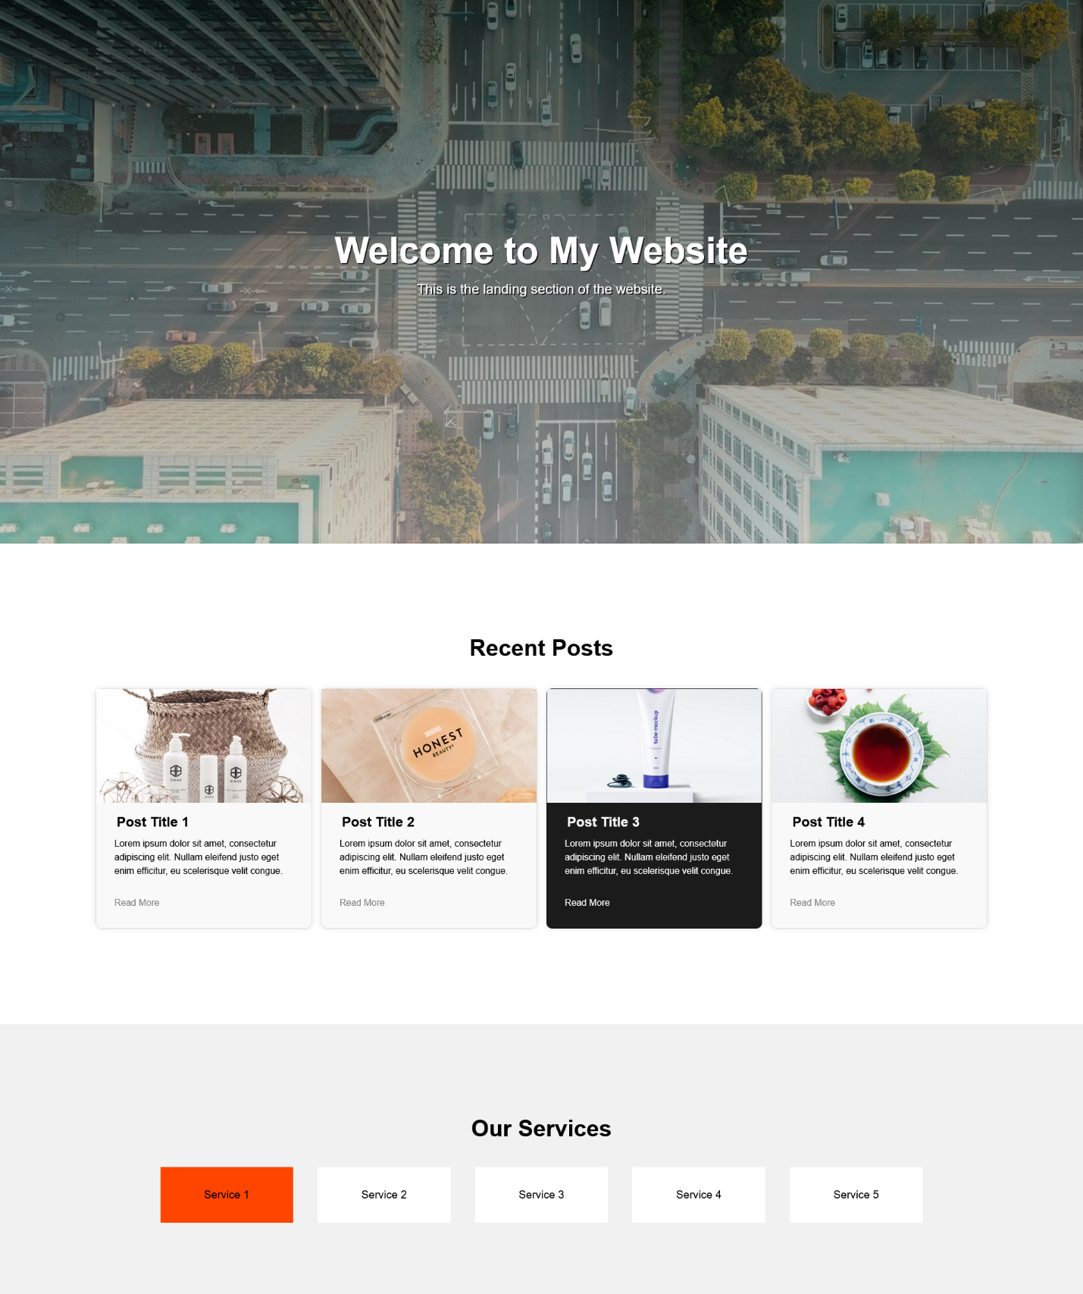

The whole web page should be divided into three sections (landing, blog, and services) and should look like this.

Recent Posts third item is a Featured Item, it was set by a title attribute with a value of Featured Item. It should look different among the rest of the Recent Posts. For easier checking the styles should look like this.

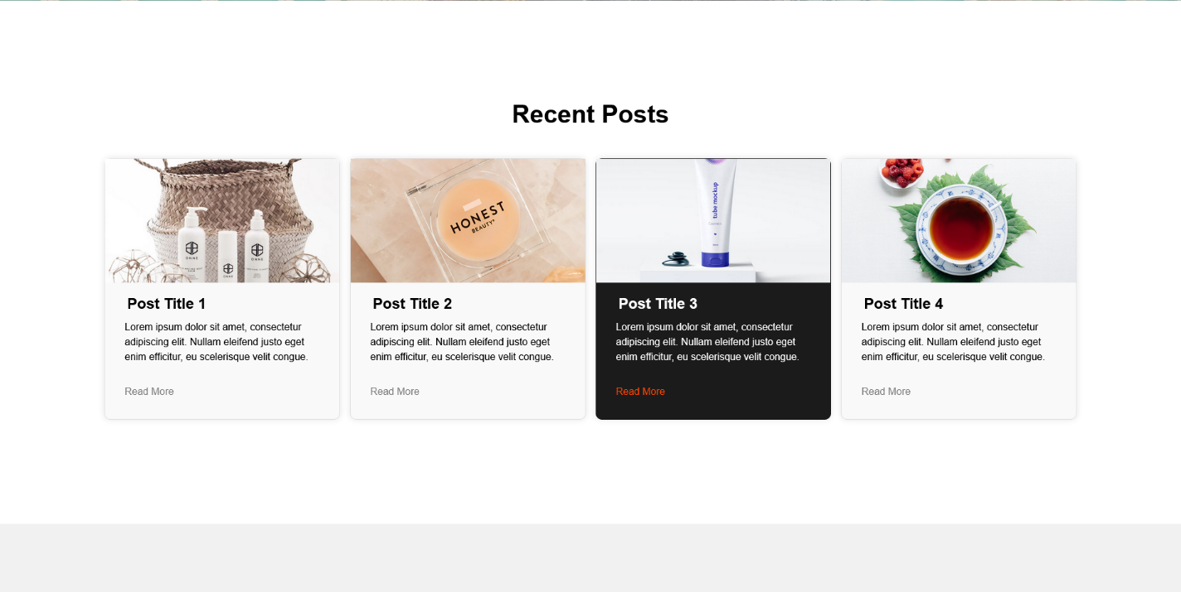

When you hovered on the Read More button the link text should have a change in color. Any color will do this time.

Under the Services Section, Style the list item to look like this (refer to the image above). The layout and style should look like this. Make the first Service styling different from other services.

When hovered a light shadow should appear.

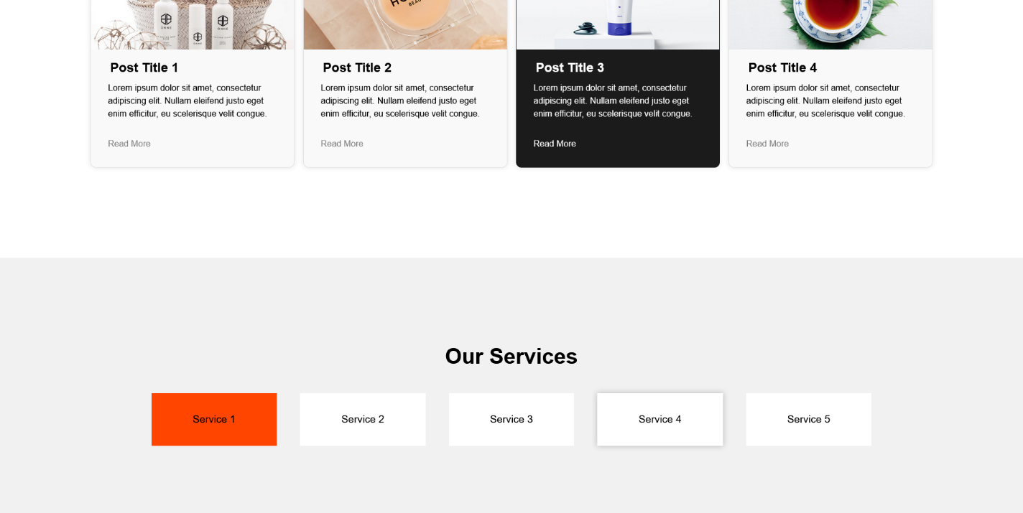

Grading

Base Grade 100

Incorrect Landing Page – 10

Incorrect Recent Post -5

Incorrect Recent Post Featured Item – 5

Incorrect Our Services Section – 5

Incorrect Our Services First Item – 5

Maximum Subtrahend is 30 points

No Submission / No git / No Video is flat 60 points

Minimum of 3 branches and 3 commits, one for each section

The index file is given including all the images needed. You only need to create the CSS File. Do not modify the code of the index.html